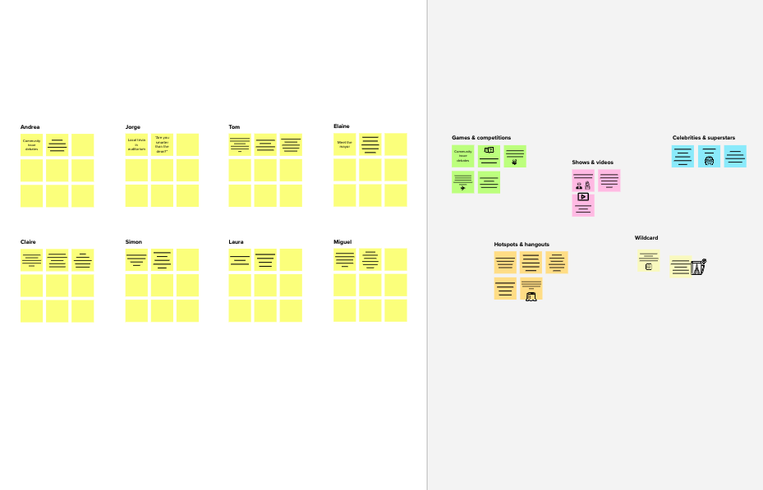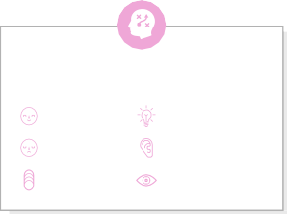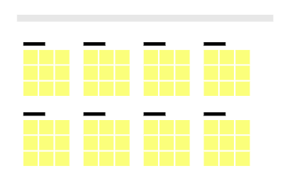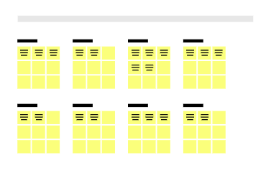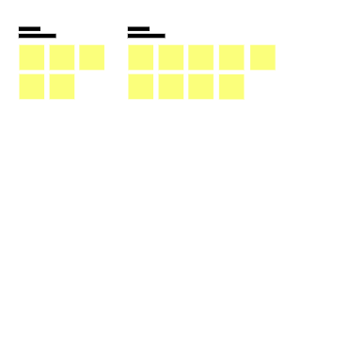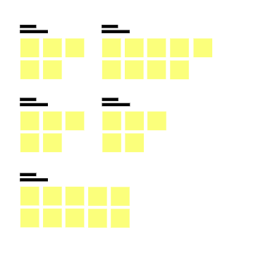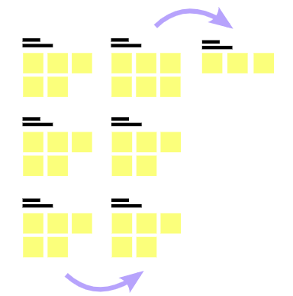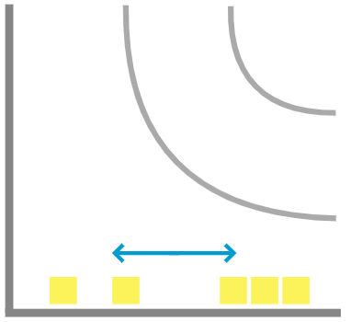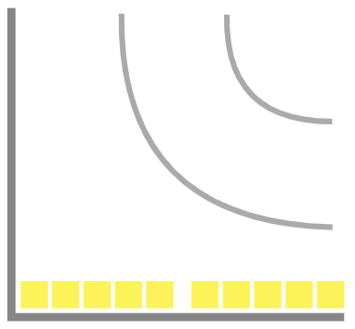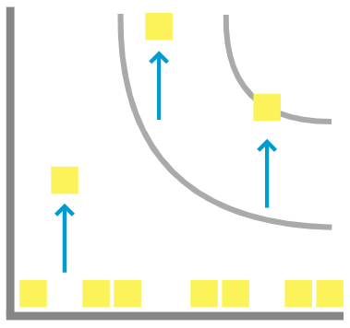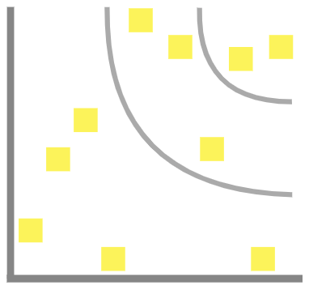

# Brainstorm

**TIP**

Add customizable tags to sticky notes to make it easier to find, browse, organize, and categorize important ideas as themes within your mural.

**TIP**

You can select a sticky note and hit the pencil [switch to sketch] icon to start drawing!

**TIP**

Participants can use their cursors to point at where sticky notes should go on the grid. The facilitator can confirm the spot by using the laser pointer holding the **H key** on the keyboard.

### Before you collaborate

A little bit of preparation goes a long way with this session. Here’s what you need to do to get going.

**10 minutes**

**1**

### Define your problem statement

What problem are you trying to solve? Frame your problem as a How Might We statement. This will be the focus of your brainstorm.

**5 minutes**

**2**

### Brainstorm

Write down any ideas that come to mind that address your problem statement.

**10 minutes**

**3**

### Group ideas

Take turns sharing your ideas while clustering similar or related notes as you go. Once all sticky notes have been grouped, give each cluster a sentence-like label. If a cluster is bigger than six sticky notes, try and see if you and break it up into smaller sub-groups.

**20 minutes**

**4**

### Prioritize

Your team should all be on the same page about what's important moving forward. Place your ideas on this grid to determine which ideas are important and which are feasible.

**20 minutes**

### After you collaborate

You can export the mural as an image or pdf to share with members of your company who might find it helpful.

**Quick add-ons**

# & idea prioritization

**PROBLEM**

**create an email campaign in mailchimp**

#### Use this template in your own brainstorming sessions so your team can unleash their imagination and start shaping concepts even if you're not sitting in the same room.

**A Team gathering**

Define who should participate in the session and send an invite. Share relevant information or pre-work ahead.

**B Set the goal**

Think about the problem you'll be focusing on solving in the brainstorming session.

**C Learn how to use the facilitation tools**

Use the Facilitation Superpowers to run a happy and

SRIRAM SUNDAR

verbal or written feedback they provide

**KRITHiCK R**

**+ A Share the mural**

**Share a view link** to the mural with stakeholders to keep

them in the loop about the outcomes of the session.

set clear campaign goals

**B Export the mural**

Export a copy of the mural as a PNG or PDF to attach to emails, include in slides, or save in your drive.

follow up with post - campaign analysis

**10 minutes** to prepare

captures explicit statements from the audience

regarding their needs

anxious about the email's effectiveness

,excited about the potential results

need to grab audience's attention and provide value

**1 hour** to collaborate

**2-8 people** recommended

productive session.

[**Open article**](https://support.mural.co/en/articles/2113740-facilitation-superpowers)

action taken after reading the email

consider what they might be thinking when receiving your email

##### Key rules of brainstorming

t lling lines As

craf compe subject

and CT

design visually appealing emails

ensure regulatory compliance

To run an smooth and productive session

##### Keep moving forward

**Strategy blueprint**

Define the components of a new idea or strategy.

[**Open the template**](https://app.mural.co/template/e95f612a-f72a-4772-bc48-545aaa04e0c9/984865a6-0a96-4472-a48d-47639307b3ca)

**Customer experience journey map**

use automation for efficiency

Stay in topic.

Defer judgment.

Encourage wild ideas.

Listen to others.

Understand customer needs, motivations, and obstacles for an experience.

[**Open the template**](https://app.mural.co/template/b7114010-3a67-4d63-a51d-6f2cedc9633f/c1b465ab-57af-4624-8faf-ebb312edc0eb)

monitor and adjust in real-time

segment your email list

Go for volume. If possible, be visual.

MOHAMED SANAULLAH AND PAVITHRAN

**ESWARAN**

**Strengths, weaknesses, opportunities & threats**

Identify strengths, weaknesses, opportunities, and threats (SWOT) to develop a plan.

|  |  |
| --- | --- |
|  |  |
|  |  |

[**Open the template**](https://app.mural.co/template/6a062671-89ee-4b76-9409-2603d8b098be/ca270343-1d54-4952-9d8c-fbc303ffd0f2)

[**Share template feedback**](https://muralco.typeform.com/to/CiqaHVat?typeform-source=app.mural.co)

**Person 4**

**Template**

subject line and preheader text

goals and challenges of the audience

the user might want to track the success of the campaign

the user seeks user- friendly experience

track and analyse performance

optimize for email devices

personalise content for recipients

**-**

interactions with links,buttons and calls to action

researches email design best practices ,content and images

,drafts email copy

##### - Feasibility +

Regardless of their importance, which tasks are more

feasible than others? (Cost, time, effort, complexity, etc.)

**Need some inspiration?**

See a finished version of this template to kickstart your work.

[**Open example**](https://app.mural.co/template/e5a93b7b-49f2-48c9-afd7-a635d860eba6/93f1b98d-b2d2-4695-8e85-7e9c0d2fd9b9)